# Appendix I

# Examples of stimuli used in email legitimacy task

1) Phishing email purporting to come from Amazon

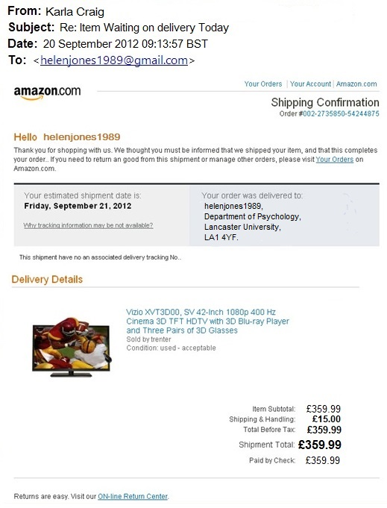

2) Phishing email purporting to come from NatWest

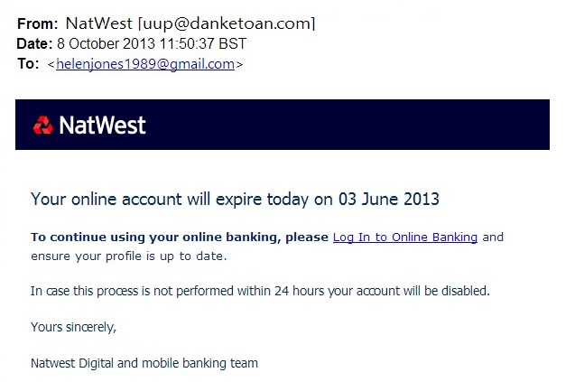

3) Legitimate email from NUS Extra

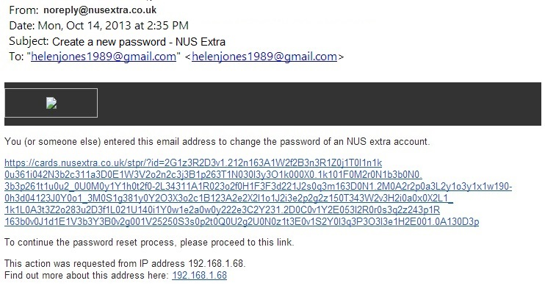

4) Legitimate email from PayPal

